Parent Signature _________________________

Name__________________ Date_________________

**Study Guide: Southwest Region**

**Southwest Region Test Date: __________________________**

**What to Study:**

* 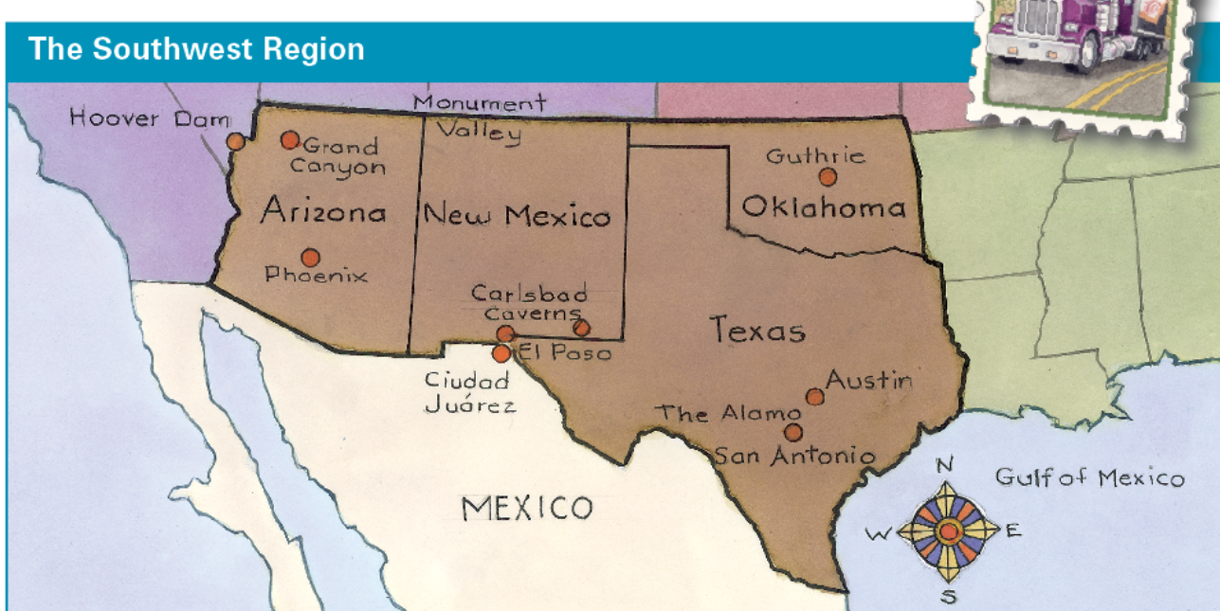Study the questions you answered on your organizer or in Seesaw during our Southwest tour.
* The notes below
* Reread Chapter 10 in TCI online and quiz yourself on the vocabulary cards.

**Resources**

* Social Studies Ch. 10 Southwest vocabulary organizer
* Chapter 10 in the Social Studies textbook and TCI online: The website is a great resource to help you study! On it you will find textbook pages, notecards, and a practice quiz!

**Southwest Region**

**Monument Valley:** Navajo Indian Reservation; Navajos adapted to life in the desert by raising sheep and growing corn even with little rainfall.

**Phoenix, Arizona:** people adapted to the climate because of 3 “A”s: air conditioning, aqueducts, and automobiles.

**Hoover Dam:** slows the rush of water down the Colorado River during flood times

**Grand Canyon:** deep narrow valley with steep sides, 277 miles long & 1 mile deep

**Carlsbad Caverns, New Mexico:** large cave where hundreds of thousands bats sleep during the day.

**El Paso and Juarez:** border cities separated by the Rio Grande. People moved to these towns for the many factory jobs.

**San Antonio, Texas:** Texas freedom fighters fought the Mexican Army at the Alamo in 1836 to try to win independence for Texas..

**Austin, Texas:**  capital city where the government is located. Members of the legislative, executive, and judicial branch work there.

**Guthrie, Oklahoma:**  settled in 1889 in a one-day land rush. Settlers that cheated and entered early were called “Sooners.”

